**Documentation**

**About Website**

Scheduler Web App is a Scheduling website designed for "CSE Department" where the features allows the students to submit their weekly preferences for attending class personally/remotely. It also assigns available seats to students to choose their preference of attending class and it also provides the faculty with a roster of who has been cleared to attend the class.

**Functionalities**

#Class Information Page

1. This page contains

* Subject Code and Subject Details.
* Teachers Credentials (Name, E-mail, Subject Code, Password).
* Subject Code and Timings (per week).

#Signup for Teachers

1. Teachers have to enter their email id, password, subject code, subject name (reference – Class Information Page).
2. Teachers after providing their correct details and submitting will be redirected to a **Students Details Page** where they will be able to see students details as (Full Name, Date of Birth, and whether they have opted for offline/online) according to the subject codes and email-id’s assigned to them, (reference – Class Information Page).

#Registration for Students

1. Students have to register themselves by providing their (Full Name, Date of Birth, Roll No., Subject Code, Online/offline Checkbox, and Subject Name).
2. They can refer to class timings, subject code and subject name from class information page.
3. They have to provide subject code and click on **find available seats** to know the status of seats (available, online, offline seats) of particular subject code, and hence can decide whether to choose offline/online as per their choice.

**Validation**

#For Teacher’s –

* Teachers can’t Login with

1. Different email-id and same subject code (example – [teacher7@gmail.com](mailto:teacher7@gmail.com) and CS1603).
2. Same email-id and different subject code (example – [teacher1@gmail.com](mailto:teacher1@gmail.com) and CS1604).
3. Have to enter same credentials provided in class information page.
4. Proper and valid email address.
5. Password (if clicked then have to fill, it can’t be null).
6. Teachers have to enter correct email-id and correct subject code to proceed further (correct password and correct subject name not required).

#For Students -

* They first have to give proper subject code and have to click on “**Find Available Seats**” button to know status of seats, then only they will be able to submit their entries and register.
* Enter valid Subject Code (reference – Class Information Page).
* Different Student name with same Roll Number are not valid (i.e their registration details will not be shown in **student details page** for any particular subjects).
* Same Student’s with different Roll Number are also not valid (i.e their registration details will not be shown in **student details page** for any particular subjects).

**Backend Details**

#Name of JS Files and their use –

* **User.j**s – For Handling all backend things related to teachers like (Storing the teacher’s details in database, redirecting teachers to student details page after providing their correct credentials).
* **User1.js** – for handling all backend things related to students like (storing their details in database, validating their subject code and roll number details).
* **User2.js** – For handling available seats, offline seats, online seats and storing them in database.
* **Index**.**js** – For handling the port, and all other JS files in backend.

**Database Details**

* **users** – Contains Teachers details and bcrypted password ,
* **user1** – Contains Students details,
* **user2** – Contains Seats details.

**Limitations** –

* In Signup for teacher’s page – if user enters invalid subject code and invalid email id (not from class information page) and submit then they will be redirected to a blank page.
* Scheduler Web App doesn’t include the feature as – same students can’t enrol with same credentials and **different subject codes provided in class information page** (i.e one student can enrol in one subject only not multiple subjects).

**Feature’s Key Points -**

* This Portal is completely handled by Admin, Timings of class will be changed by Admin week wise.
* Teachers have to enter the same credentials provided to them or else they will not be allowed to proceed further.
* Students also have to enter same subject code given in Class information Page or else they will not be allowed to register themselves.
* Students have to click on "Find Available Seats" after providing Subject Code or else they will not be able to proceed further.

**Some Screen shots of the Scheduler Web App – 1.Home Page**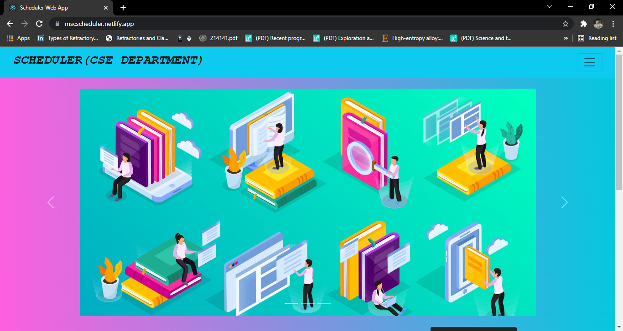

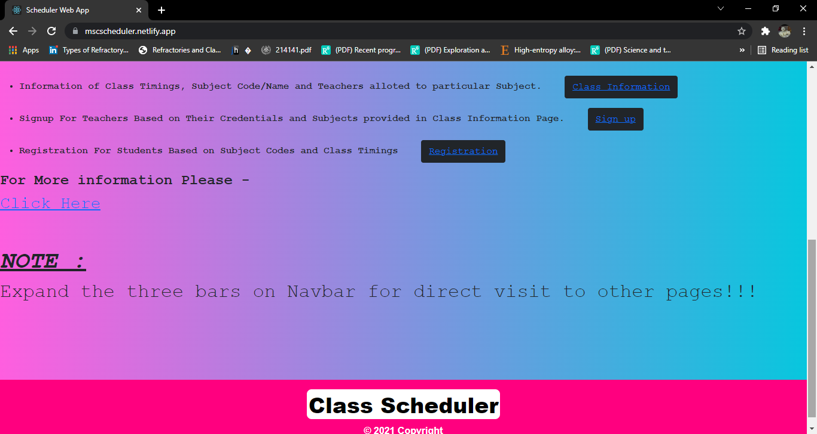

1. **SignUp for Teachers -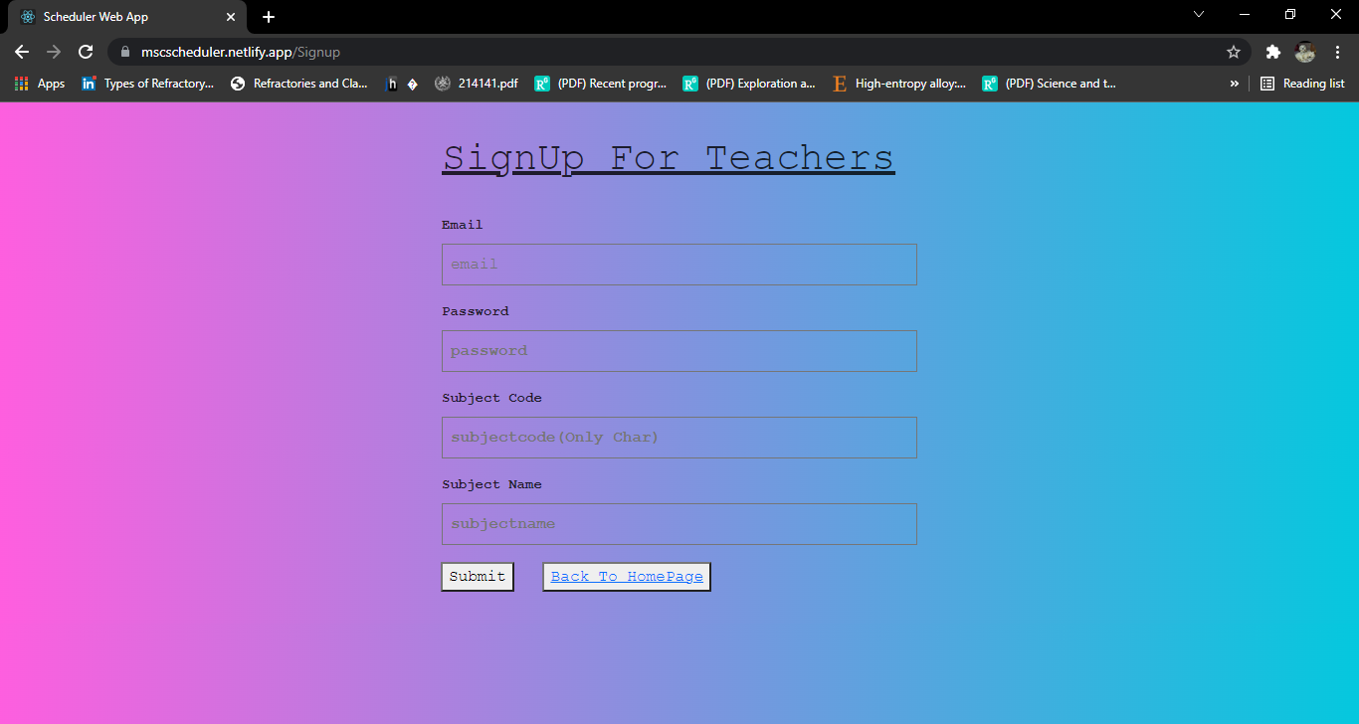3.Registration for Students –** 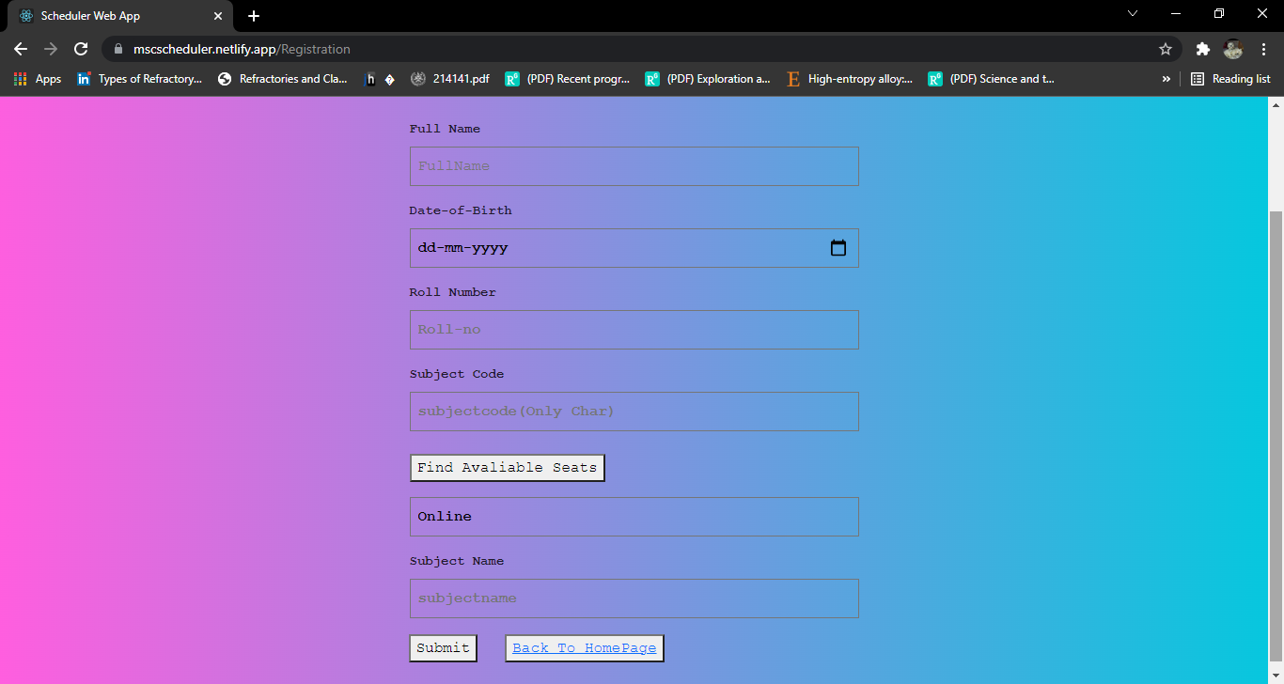
2. **Class Information Page**

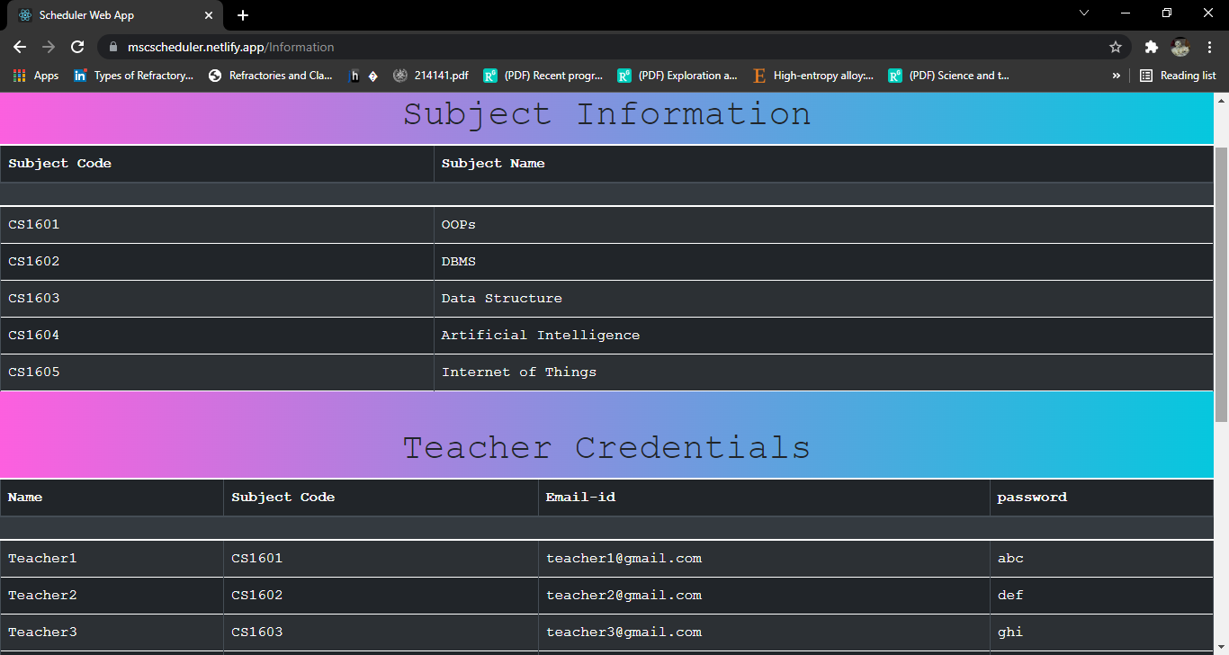

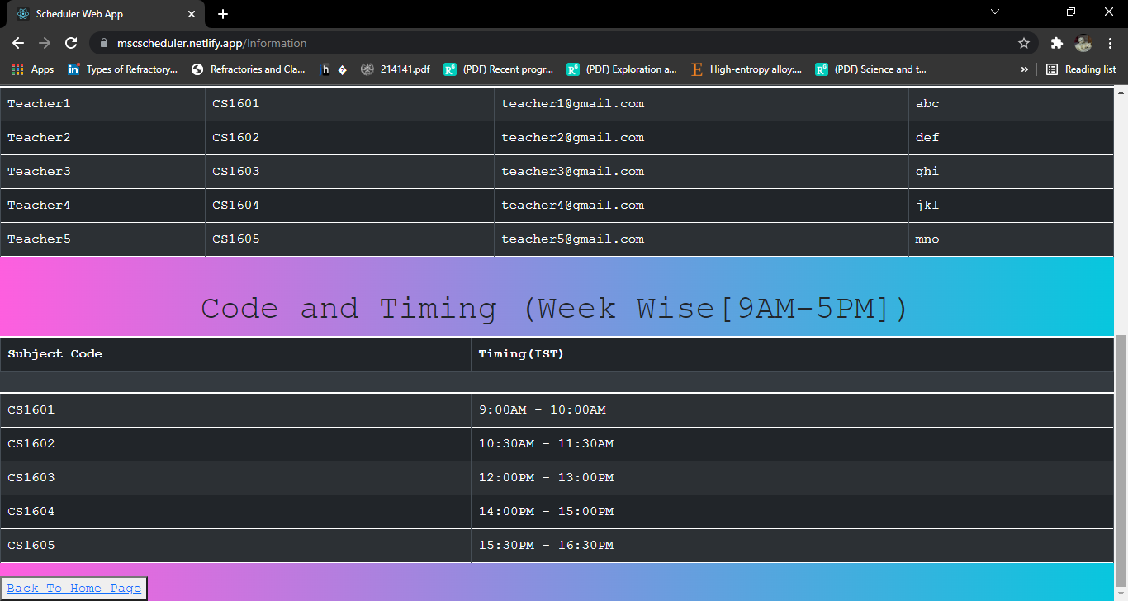

1. **Teachers have to provide credentials as (*Correct email-id and correct subject code)**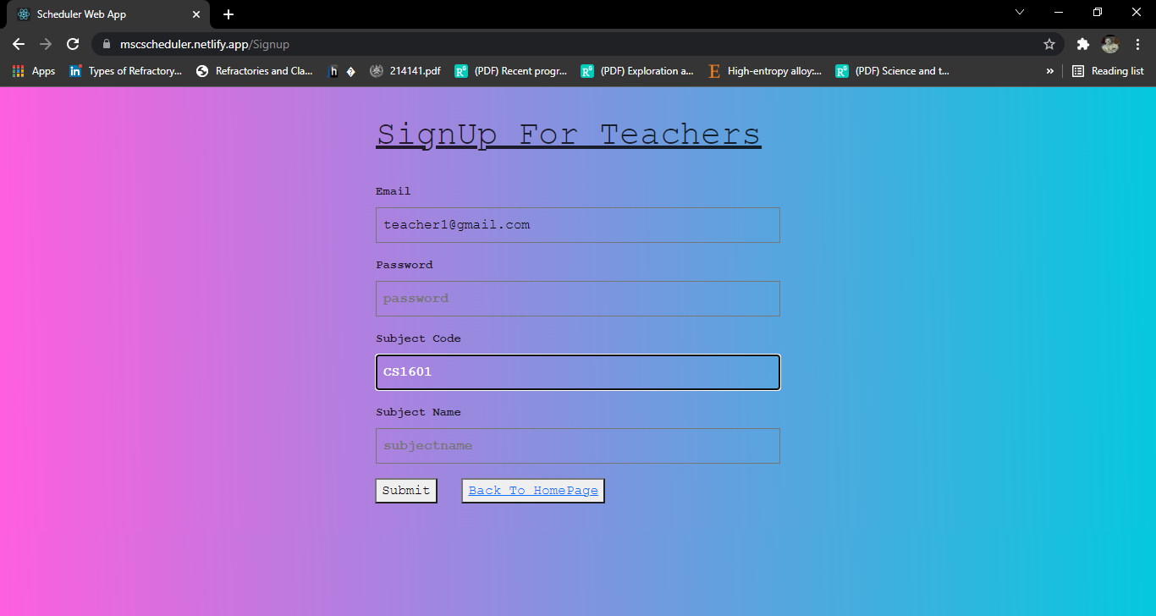
2. **After submitting the correct details teachers will be redirected to students detail page for the particular subject code they have entered and will be able to see students opted for online/offline.**

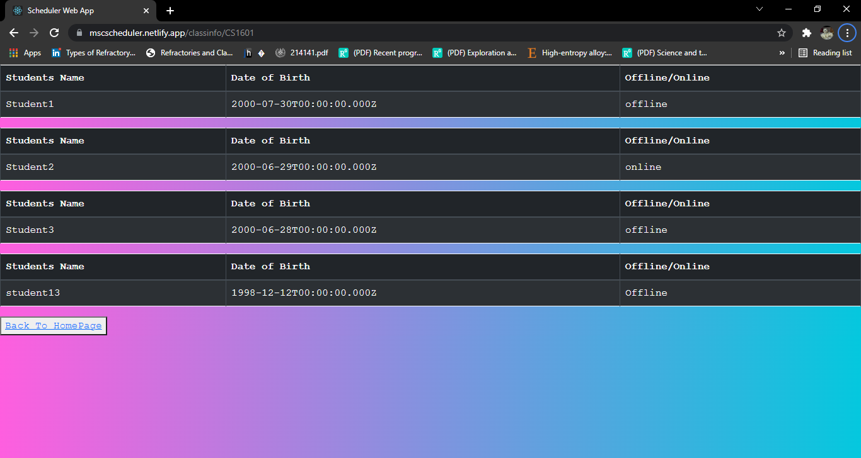

1. **In students registration they have to click on “find available seats” to know status and then can proceed further.**

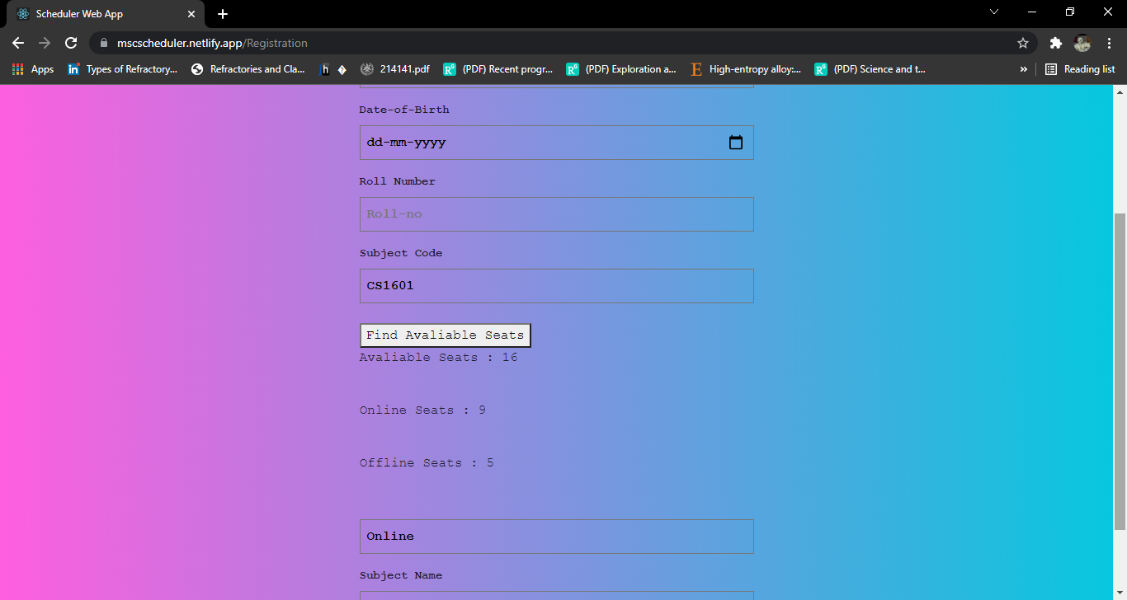

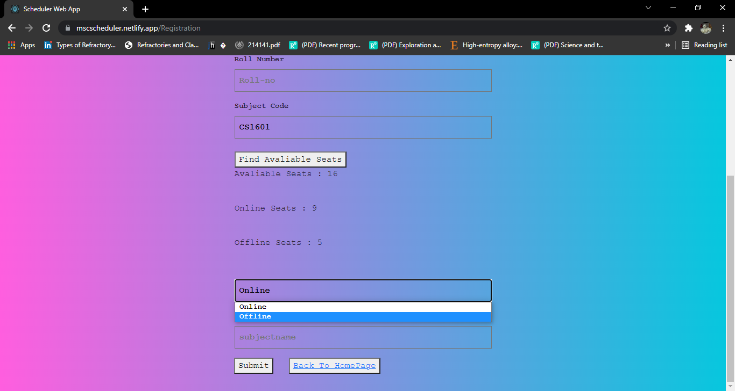

1. **About Website Page**

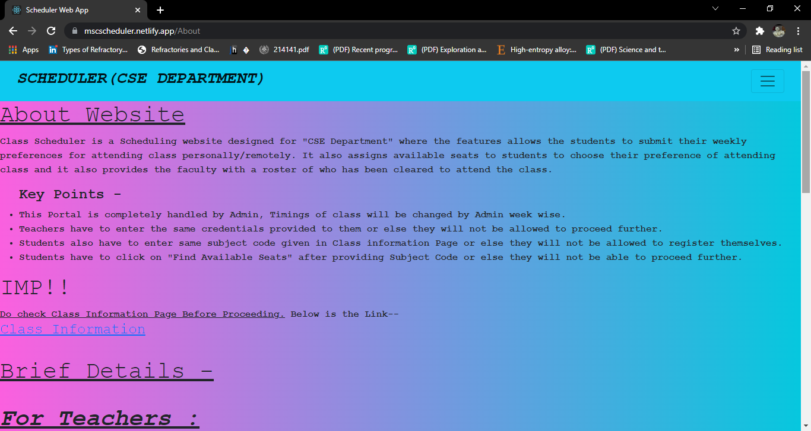

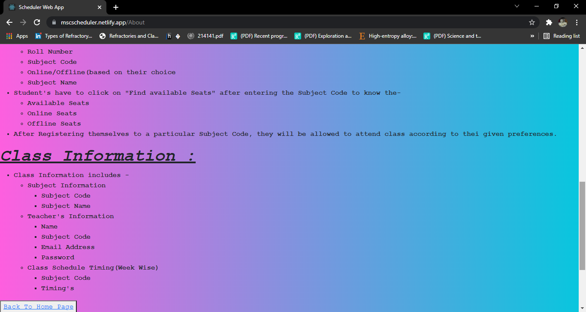

1. **Responsive NavBar**

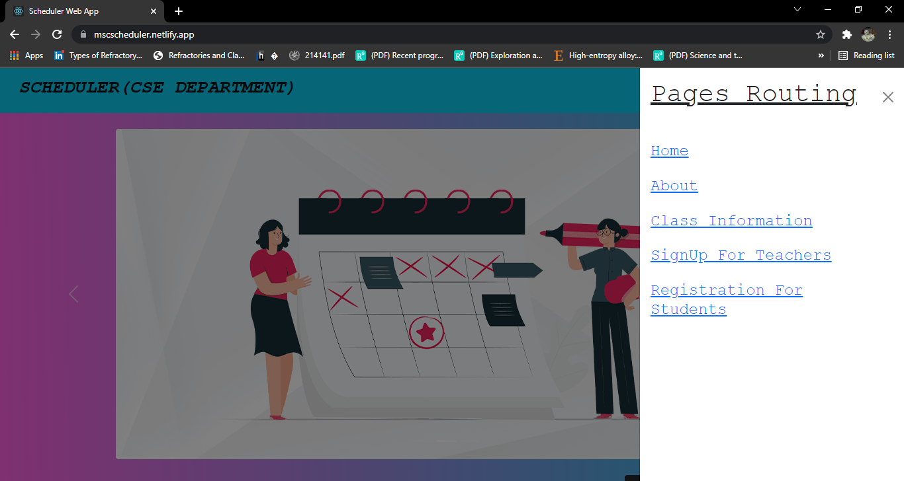

**Database :-**

**Users (for storing teachers details credentials) –**

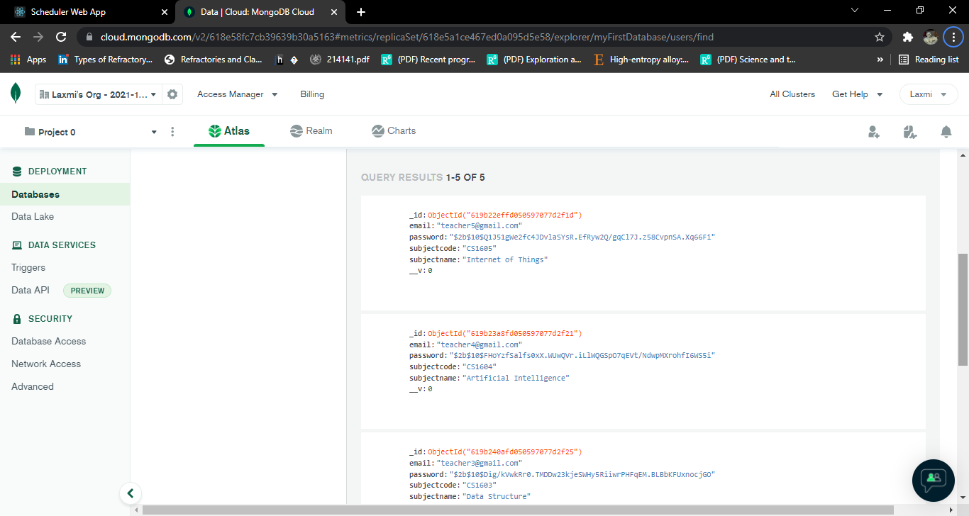

**User1(for storing students registration details (subject code wise)**

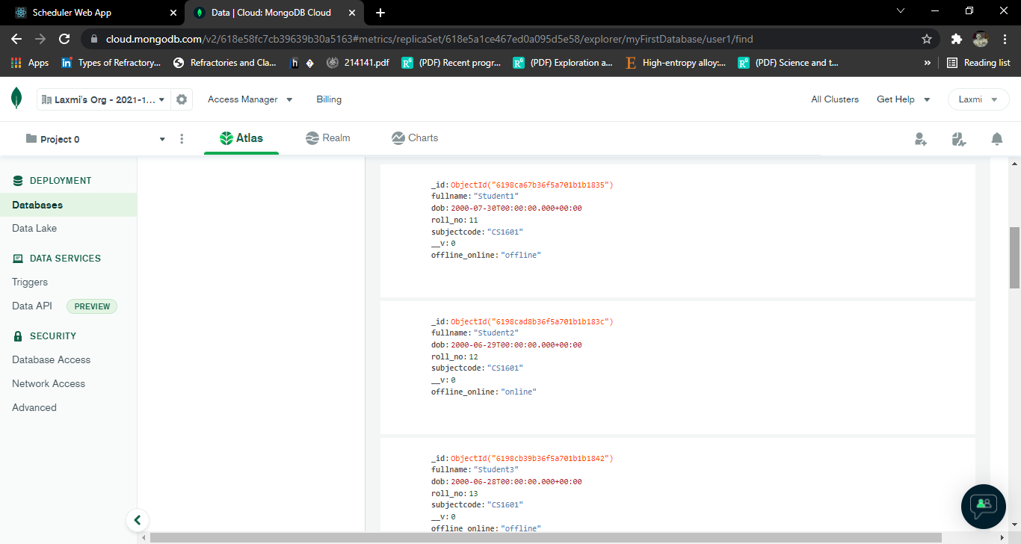

**User2(for storing seats details)**

